**ONLINE TICKET BOOKING**

**SYSTEM**

**STANDARD GAUGE RAILWAY**

**EMMANUEL KARIUKI NGUGI**

**A Project Proposal for System Development Submitted to Human Resource Development, School**

**Of Business, Department of Business Administration, In Partial Fulfilment of the Requirement For The Degree Of Bachelor Of business and information technology.**

**2017**

## **DECLARATION**

**Declaration by the student**

I declare that this project is my original work and has not been exhibited or published in any way and has never been presented for any awards in any institution.

NAME: EMMANUEL KARIUKI NGUGI

REG. NO. HD232-5559/2014

Signature………………………… Date……………………

**Declaration by the Supervisor**

This project has been submitted for examination with my approval as the supervisor.

Name…………………………………. Signature …………………Date………….

## **ACKNOWLEDGEMENT**

I would like to acknowledge my supervisor Mr. Kepha, I recognize opinions, critics by my fellow students, and finally all praise to God for the state of sound mind, good health, and gift of life for this period I ventured to do my project.

## DEDICATION

This project and all related works, is dedicated to my parents Mr. and Mrs. Ngugi who have been there for me, taught me, believed in me, and passed on the art of hard work. I will do my best while developing my project to display my dedication in my studies

## **ABSTRACT**

SGR transport system is an online platform that will help man ease work from going to the railway station and start making long queues instead you only need to interact with us on our website and book online.it reduces the cost while moving from one place to another. As compared to the old means the SGR is much fast hence taking a very short time from one destination to another. The prices are also favoring the small business men/women in a manageable situation to move from place to place doing their business. It is even getting much easier where you have to just send a short message and you get a confirmation message that’s at the clients end.at the moment the process is going on very successful in other countries such as united states.In this regard, the implementing agency, KRC and the Ministry have assured the communities along the path of the railway line that their interests will be paramount before, during and after the construction period. Cooperation between the contractor and the local communities will be crucial and so is the involvement of County governments.

The Ministry and Kenya Railways Corporation in collaboration with the Kenya Private Sector Alliance(KEPSA) organized a SGR Symposium on 16th June 2014 for local contractors and business community. The objective of the symposium is to engage the private sector on available investment opportunities and how best to tap them during and post-SGR construction. . I am working to have such a system implemented in our country very successful.

**TABLE OF CONTENTS**

**DECLARATION** ii

**ACKNOWLEDGEMENT** iii

**DEDICATION** iv

**ABSTRACT** v

CHAPTER ONE: INTRODUCTION 1

**1.1BACKGROUND** 1

1.2**PROBLEM STATEMENT** 2

**1.3 MAIN OBJECTIVES** 3

**1.3.1 SPECIFIC OBJECTIVES** 3

**1.4 RESEARCH QUESTIONS** 3

**1.5 JUSTIFICATION** 3

CHAPTER TWO: LITERATURE REVIEW 5

**2.1 INTRODUCTION.** 5

**2.2 ONLINE BOOKING.** 6

**2.3BENEFITS OF ONLINE BOOKING.** 6

**2.4 CHALLENGES OF ONLINE BOOKING.** 6

**2.5STANDARD GAUGE RAILWAY HISTORY** 7

CHAPTER THREE: METHODOLOGY 8

**3.1 INTRODUCTION** 8

**3.2 SYSTEM DESIGN** 8

3.2.1RAPID APPLICATION PHASES 8

**3.2.2 advantages of rad model over other traditional methodologies.** 9

**3.3 Software requirements** 10

**3.3.1 Development tools** 10

**3.4 Target population** 10

**CHAPTER 4** 11

SYSTEM ANALYSIS DESIGN 11

4.1 Introduction 11

**4.2Use case diagram** 11

11

**4.3State chart Diagram** 12

**4.4Data flow diagram** 12

**4.5Database design** 13

**4.6 Code segment** 13

**4.6.1 index** 13

CHAPTER 5 24

IMPLEMENTATION, SUMMARY, CONCLUSION AND RECOMMENDATION 24

**5.1 Introduction** 24

**5.2 Implementation** 24

**5.2.1 Home Page** 24

**5.2.2 Login** 25

**5.3 Summary conclusion and recommendations** 27

**5.3.1 Summary** 27

**5.3.2 Conclusion** 27

**5.3.3** **Recommendation** 27

REFERENCEs 28

# CHAPTER ONE: INTRODUCTION

## **1.1BACKGROUND**

The current levels of urbanization within Nairobi have led to increased population within the city most residing in areas around Nairobi. This has led to a great demand of transportation services which could not be met by the road transport only. The result of this high demand is chronically snarled traffic on major roads and highways. The government hence had to be committed to explore alternative means including the construction and improvement of commuter rail system in Nairobi and environs. (Wallach, (2004).

In order to address the challenges of railway transport services, the Government has commenced the development of a Standard Gauge Railway (SGR) from Mombasa to Nairobi. This is the first phase of an ambitious regional railway development programmer in Kenya, Uganda, Rwanda and South Sudan. The new railway will supplement road transport, thereby increasing the efficiency of the Northern Corridor and significantly reduce the cost of road maintenance. This will lower the cost of doing business in the region thereby improving trade and attracting investments. On 28th August, 2013 Kenya, Uganda and Rwanda governments signed Tripartite Agreement committing to fast track the development of the railway to their respective capital cities. South Sudan has since come onboard as an interested stakeholder in the project.

Regional economic interests have therefore worked in favor of the project. In this regard, the SGR line will snake its way from the port of Mombasa to Kigali through Kampala with a branch line to Juba. In Kenya there will be a branch line to Kisumu from Eldoret. As a necessary transport mode, the project is therefore a key component of the Northern Corridor.

Kenya is vigorously pursuing the development of the first phase of the SGR from Mombasa to Nairobi. The Kenya Railways Corporation (KRC) is the implementing agency of the SGR, while China Road and Bridge Corporation is the contractor (KBRC).( Hall, (2005).

In this regard, the implementing agency, KRC and the Ministry have assured the communities along the path of the railway line that their interests will be paramount before, during and after the construction period. Cooperation between the contractor and the local communities will be crucial and so is the involvement of County governments.

The Ministry and Kenya Railways Corporation in collaboration with the Kenya Private Sector Alliance(KEPSA) organized a SGR Symposium on 16th June 2014 for local contractors and business community. The objective of the symposium is to engage the private sector on available investment opportunities and how best to tap them during and post-SGR construction.

## **1.2PROBLEM STATEMENT**

There being a very big problem in our country of transportation, congestion of people in the railway stations, long queues and consumption of too much time in confirmation of the railway tickets. The government has come up with an idea of constructing more railway stations and terminus to curb the problems. I have decided to come up with an idea of creating a platform where people will book train tickets online without wasting much time.

The route to be used should also be well defined and conversant to the passengers, at sometimes due to human error or inconvenience one may need to cancel the ticket; this should be done early enough so that the seat may be given to someone else.

The newly launched railway transportation is able to tell time of departure and also the exact time of arrival and most probably time for the next board as compared to the former means of transport.

A problem which has also been there for quit sometime is record keeping where information got lost which can’t even help in case of need in future reference. It’s important to have a system which is easy to retrieve information.

The site being created for the booking should have a user friendly interface to the user and the administrator.

Economic growth it will be easy to import and export goods from neighboring countries leading to growth of Kenya economy. business people have gathered confidence that the goods produce and farm produce will be able to reach their targeted markets in time and more industries will emerge. The new rail transport is using electricity thus reducing use of other forms of energy. social economic growth has been seen long the rail way terminus this has improved trade.it has also improved local tourism sector in Kenya thus benefiting the jobless Kenyan youths in the sector of hospitality The rail transport SGR has shown that Kenya has improved much in transport sector and has embraced digital transport. I decided to come up with an SGR system to help curb the situation.

## **1.3 MAIN OBJECTIVES**

Developing a user friendly system that will accommodate all clients in terms of cost, time and also reduce congestion of travelers maintaining the security levels for the system and the users themselves.

## **1.3.1 SPECIFIC OBJECTIVES**

1. To develop a user friendly interface for both the admin and user.
2. To design an online system that is accurate, quick and efficient.

## **1.4 RESEARCH QUESTIONS**

1. How will the system be developed?
2. How will the system be designed and language to use?

## **1.5 JUSTIFICATION**

This project will improve the transportation process. It will reduce the time wasted in ticket booking manually as well as enhance proper queue management. The system which will be the final product of this project will also enhance the image of the transport sector.

The project is expected to reinvigorate existing urban centers that are situated along Mombasa-Nairobi highway due to business opportunities associated with such projects. For

example, apart from the 33 crossing stations, 5 stations will be constructed at Mariakani, Voi, Mtito Andei, Sultan Hamud and Athi River.

Definitely, these urban centers will immensely benefit both in terms of urban growth and business activities accruing from the SGR project.

The stations will be served by workshops for locomotives, rolling stock facilities that will require ample supply of electricity and water not to mention signaling, communications

and ICT systems.

In a nutshell, the SGR project will be a game changer as far as railway development is concerned in the Kenya.

The project is gargantuan one to say the least and presents many challenges that have to be overcome. Foremost is the support of Kenyans, especially those who will be affected by the actual construction of the SGR.

In this regard, the implementing agency, KRC and the Ministry have assured the communities along the path of the railway line that their interests will be paramount before, during and after the construction period.

# 

# CHAPTER TWO: LITERATURE REVIEW

## **2.1 INTRODUCTION.**

The current levels of urbanization within Nairobi have led to increased population within the city most residing in areas around Nairobi. This has led to a great demand of transportation services which could not be met by the road transport only. The result of this high demand is chronically snarled traffic on major roads and highways. The government hence had to be committed to explore alternative means including the construction and improvement of commuter rail system in Nairobi and environs.

SGRin Consideration of the current trend of urbanization within Nairobi and its environs, there is demand for an effective, fast and reliable public transportation system. Rail transport has been restructured in order to improve the current situation. In a huge city like Nairobi, which is mainly served by roads, it is imperative that commuters know all the available and convenient modes of transport to take in order to arrive to their destinations. With the improvement of rail system, commuters will need to have a rail information system. This brings about the need for a public transport information system. With the availability of the information system, all the information required by the users will be available to them at the click of a button. This will also put an end to indecisiveness of commuters regarding their transport needs. The planners and managers of public transportation will be able to make informed decisions about the commuter needs.

## **2.2 ONLINE BOOKING.**

Online booking is where one gets online either through the internet or a direct message to get a ticket without wasting a lot of time and also the hustle to and from the railway station. I as the developer I am developing a user friendly interface that will be very easy to use and understandable to the clients. Any communications or transactions done online by the client and approved by the administrator are protected by end to end encryption for security purposes.it will also keep track of a HALT station.

A halt is a small station, usually unstaffed and with few or no facilities. In some cases, trains stop only on request, when passengers on the platform indicate that they wish to board, or passengers on the train inform the crew that they wish to alight. Goods stations deal mostly with the loading and unloading of goods and may well have marshalling yards (classification yards) for the sorting of wagons.

## **2.3BENEFITS OF ONLINE BOOKING.**

Reduce congestion at the ports in Kenya, securing the port as a preferred facility in the region.

Reduce cost of transportation in the region because transport facility is nearly available.

Speeds up industrialization this is because people are migrating from one place to another hence leading to a growth of industrialization.

Protect the environment through reduced carbon emissions

Contribute to growth of GDP.the economic level goes higher which results to a higher growth in GDP in our country.

## **2.4 CHALLENGES OF ONLINE BOOKING.**

Budgetary constraints; the estimation of the budget put in place by the contractors is not enough for what is required to reach the goals that are expected. Leading to a delay in the time that is set aside for the completion of the project.

High Capital Cost for infrastructure development.; the cost of buying infrastructure has really gone up making it very difficult for the government to reach the standards of construction needed.

Fluctuations in the foreign currencies. The conversion of the Kenya shilling to other currencies and the vice versa has really depreciated hence going at a certain margin loss.

Huge development and maintenance. The railway line system is very difficult to develop and maintain because of its expensive cost of maintenance.

## **2.5STANDARD GAUGE RAILWAY HISTORY**

STA Kenya Railways Corporation (KRC), also Kenya Railways (KR) is the national railway of Kenya. It was established in 1977 after the breakup of the east African community. The original Uganda Railway was transformed into the East African Railways and Harbors Corporation (EARC) after World War I. The EARC managed the railways of Uganda, Kenya, and Tanganyika until the collapse of the East African Community in 1977. Subsequently KR took over the Kenyan part of the EARC. Kenya Railways Corporation (KRC) was hence established in 1978 under the Kenya Railways Act Cap397 of the Laws of Kenya. It is a wholly owned government parastatal that took over the operations of the defunct East African Railways Corporation (EARC), following the demise of the then East African Community (EAC) in 1977. The Act was revised in 1986, and it details the duty of the corporation to provide coordinated and integrated rail and inland waterway transport services, port facilities. In Consideration of the current trend of urbanization within Nairobi and its environs, there is demand for an effective, fast and reliable public transportation system. Rail transport has been restructured in order to improve the current situation. In a huge city like Nairobi, which is mainly served by roads, it is imperative that commuters know all the available and convenient modes of transport to take in order to arrive to their destinations. With the improvement of rail system, commuters will need to have a rail information system. This brings about the need for a public transport information system. With the availability of the information system, all the information required by the users will be available to them at the click of a button. This will also put an end to indecisiveness of commuters regarding their transport needs. The planners and managers of public transportation will be able to make informed decisions about the commuter satisfaction.

# 

# CHAPTER THREE: METHODOLOGY

## **3.1 INTRODUCTION**

Methodology or system development methodology in the software engineering is a framework that is used to structure, plan, and control the process of developing an information system that include predefinition of specific were considered deliverables and artifacts that created and completed by project team to develop, at choosing of methodology factors such as knowledge base, nature of system as well as data and operational requirements.

## **3.2 SYSTEM DESIGN**

The design methodology for the research was the Rapid application development (RAD) methodology. According to Lawrence,(2012) the RAD method of software development structures the life cycle of the project in five phases (including 3 systemic)

Rapid Application Development is thus a methodology that enables organizations to develop strategically important systems faster while reducing development costs, lifespan and maintaining quality. This is achieved by using a series of proven application development techniques, within a well-defined methodology.

This causes RAD approach to use prototypes. It emphasizes a flexible approach that can adapt as the project evolves rather than vigorously defining specifications and plans correctly from the start.

### 3.2.1RAPID APPLICATION PHASES

1. **Requirement Planning** - In this phase, the frequently asked question was why the system needs to be built and answered appropriately. The system’s requirements are clearly defined and a thorough feasibility study is done from various perspectives including technical, financial, and organizational where the system users were involved fully.
2. **User design phase** - This phase involved problem identification and solution analysis. Efforts are made to predict the problems that the developers might face while creating the system. The end-deliverables of this phase determines the method of system creation and provided guidance to the developer.
3. **Construction phase** – This is the phase when the actual development of the system takes place, it entails the actual coding of the system using the specified software and hardware specifications.
4. **Implementation phase –** In this phase, the system istested for defects that are rectified, and finally installed. It is bundled along other essential activities including training and maintenance. This phase is usually split into smaller, more specific phases such as Development and Deployment and Maintenance. However, the above four phases are the most common and accepted ones.

### **3.2.2 advantages of rad model over other traditional methodologies.**

1. **Faster delivery time** - RAD reduces the project development life cycle due to a reduced requirement analysis, this is achieved by prototyping technique and usage of automated tools like CASE which enhances reuse of code rather than coding from scratch.
2. **Greater customer satisfaction** - The RAD methodology involves active participation of the customers and end users in all stages of analysis and development of the application. It is especially helpful in scenarios where the user requirements are uncertain, or not fixed.

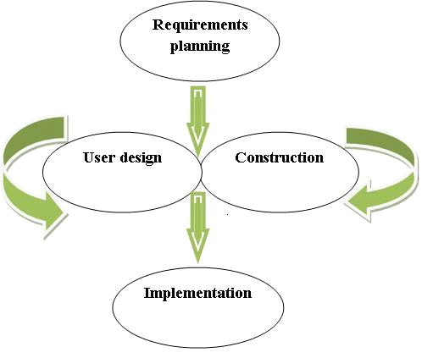

**Better project management -** In RAD, there is active participation of the management, the development teams, as well as the business owners and end users. This results to a better collaboration between all stakeholders, hence, a better understanding of the client requirements and expectations. Also, the project receives better visibility and support.

**Reduced risk -** Due to the iterative approach and prototyping, testing and integration of end user feedback happens at each stage of product development. Hence, the end product has lesser number of changes and defects, thereby minimizing the risks involved in the project.

### **3.3 Software requirements**

These are the basic requirements of the software resources needed;

1. PHP storm software for the design and coding of the website
2. WAMP/XAMPP Server for the creation of dynamic webpage

### **3.3.1 Development tools**

1. PHP

This is because it is an open source/free software, used across different platforms, it is powerful, robust and scalable. It is also web development specific and can be object oriented especially version 5. It also has great documentation in many languages.

1. Design tool –Gimp (GNU Image manipulation program)

It is a free and open-source raster graphics editor used for image retouching and editing, free- form drawing, resizing and cropping, converting different image formats. This will be used because it is expandable and extensible.

JavaScript is an open language and anyone can use it. It also shares many of the features and structures of the Java programming language, though it is not really related to Java. It was developed independently.

## **3.4 Target population**

Target population will all the clients of the station and also the administrators and developers behind the development of a successful project proposal which eventually will be implemented and accessed by the end user.

## **CHAPTER 4**

# SYSTEM ANALYSIS DESIGN

# 4.1 Introduction

This chapter contains UML diagrams that were used to represent the system. The diagrams assisted in describing, visualizing, constructing and documenting the artifacts of the system. Through the diagrams, the developer was able to reason about the system behavior, to detect errors and omissions, to understand requirements and to drive implementation. The chapter also includes database tables

## **4.2Use case diagram**

**client** **admin**

Register

Log in

Password

Book

Confirm ticket

Feedback

Log out

# 

It is used to gather requirements of a system, get an outside view of a system, identify external and internal factors influencing the system and show the interaction among the actors. In my project, the actors include the applicants who consist of students and staff and the administrator.

The users interact with the system and can view/update their profile, register as candidate, log in and out, cast vote, view results. The administrator on the other hand can login/out, view user profiles and validate candidate.

## **4.3State chart Diagram**

State chart diagram describes the flow of control from one state to another state. A state is a condition in which an object exists and it changes when some event is triggered. The State chart diagram is used to model life time of an object from creation to termination. It is used to visualize the reaction of a system by internal or external factors.

In this case, the state of the system changes when a user log on and starts the application process to request to vote. Once the user logs of the system, the system moves to another state.

## **4.4Data flow diagram**

Log out

Log in

Username status

password

## **4.5Database design**

The database design below shows

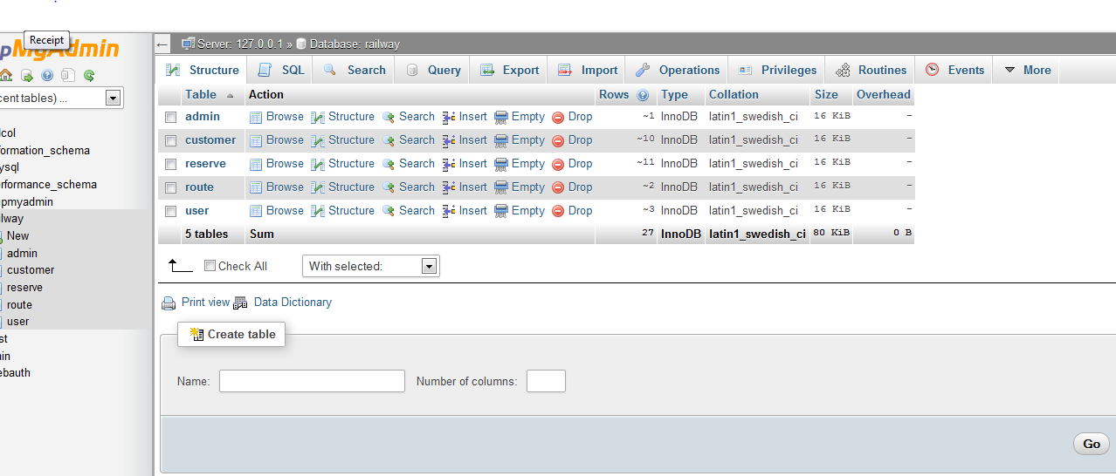

## **4.6 Code segment**

### **4.6.1 index**

<?php

session_start();

require_once('config/db.php');

?>

<!DOCTYPE html>

<html lang="en">

<head>

<meta charset="utf-8">

<title>Book Your Train</title>

<meta name="description" content="HTML framework description">

<meta name="viewport" content="width=device-width, initial-scale=1">

<!-- Styles -->

<link rel="stylesheet" type="text/css" href="css/nav_dashboard.css">

<link rel="stylesheet" type="text/css" href="css/print.css">

<link rel="stylesheet" type="text/css" href="css/nav.css">

<link rel="stylesheet" href="css/general.css">

<link href="http://fonts.googleapis.com/css?family=Raleway:400,100,200,300,600,500,800,700,900" rel="stylesheet">

<link href="http://fonts.googleapis.com/css?family=Montserrat:400,700" rel="stylesheet">

<link href="http://fonts.googleapis.com/css?family=Open+Sans:300italic,400italic,600italic,700italic,800italic,300,400,600,700,800&amp;subset=latin,cyrillic-ext,cyrillic,latin-ext" rel="stylesheet">

<!-- jQuery & jQuery UI Lib -->

<script src="js/libs/jquery-1.11.0.min.js"></script>

<script src="js/libs/jquery-ui.js"></script>

<script src="js/scriptsJsUI.js"></script>

<!-- Modernizr -->

<script type='text/javascript' src='js/libs/modernizr-2.5.3.min.js'></script>

<!-- Semantic HTML5 Support on old IE -->

<!--[if IE]>

<script src="http://html5shiv.googlecode.com/svn/trunk/html5.js"></script>

<![endif]-->

</head>

<body>

<header class="header">

<div class="container cf">

<div class="logo">

<a href="index.php" class="logo__item">

<h1 style="font-family: Delicious"><marquee><strong>Online Train Ticket Booking</strong></marquee></h1>

<!--<img src="css/images/logo.png" alt="Libro" />-->

</a>

<!--<p class="logo__item logo__item_descr">

There are many variations of passages

</p>-->

</div>

<!-- END: LOGO -->

<ul class="lang header__item">

<li class="lang__item">

<!-- <a href="#" class="lang__link">

<?php

//$cur_user = $user->get_user_info($username);

//echo $cur_user->first_name." ".$cur_user->last_name;

?>

</a>-->

</li>

</ul>

<!-- END: LANG -->

<div class="enter header__item">

<!--<a href="login.php" class="enter__item enter__item_login">Login</a>

<a href="register.php" class="enter__item enter__item_register">Register</a>

<?php //if ($user->is_logged()) include('logout.link.php');?>-->

<a href="logout.php" class="enter__item enter__item_login">Log Out</a>

</div>

<!-- END: ENTER -->

<div class="contacts header__item">

<div class="contacts__phone"><?php

if (isset($_SESSION['username'])) {

echo $_SESSION["username"];

}else{

echo "<script type='text/javascript'>alert('You must log in first'); window.location.href = 'admin_login.php';</script>";

}

?>

</div>

<!-- <div class="contacts__email">support@bookyourtrain.com</div>-->

</div>

<!-- END: CONTACTS -->

</div>

<!-- END: CONTAINER -->

</header>

<!-- END: HEADER -->

<!--<ul id="ul">

<li><a href="index.php">Home</a></li>

<li><a href="routes.php">Routes</a></li>

<li><a href="location.php">Location</a></li>

<li><a href="result.php">Search Train</a></li>

<li class="current"><a href="contact.php">Contact Us</a></li>

</ul>-->

<nav class="nav">

<div class="container cf">

<form class="search">

<input type="text" placeholder="Search">

<button type="button" class="search__btn"></button>

</form>

<!-- END: SEARCH -->

<a href="#" class="pull pull_insNav">Menu</a>

</div>

</nav>

<!-- END: WRAP NAV -->

<div class="mainSlider">

<ul class="insMainSlider cf">

<li class="insMainSlider__item" style="background: url() no-repeat center center fixed;">

<div class="container">

<div class="slider__column">

<div class="sliderTitle">

</div>

</div>

<div class="slider__column">

<?php

require ('admin_header.php');

include('config/db.php');

?>

<!DOCTYPE html>

<html>

<head>

<style>

#nav {

list-style-type: none;

margin: 20px;

padding: 20px;

overflow: hidden;

background-color: #333;

width: 100%;

}

#nav li {

float: left;

}

#nav li a {

display: block;

color: white;

text-align: center;

padding: 14px 16px;

text-decoration: none;

margin-left: 30px;

}

#nav li a:hover {

background-color: #111;

}

#hor-minimalist-b

{

font-family: "Lucida Sans Unicode", "Lucida Grande", Sans-Serif;

font-size: 12px;

background: #fff;

margin: 15px;

width: 100%;

border-collapse: collapse;

text-align: left;

}

#hor-minimalist-b th

{

font-size: 12px;

font-weight: normal;

color: #039;

padding: 8px 8px;

border-bottom: 2px solid #6678b1;

}

#hor-minimalist-b td

{

border-bottom: 1px solid #ccc;

color: #669;

padding: 6px 8px;

margin:10px;

}

#hor-minimalist-b tbody tr:hover td

{

color: #009;

}

#filter{

width: 230px;

border: 1px solid #C1DAD7;

border-left: 4px solid #C1DAD7;

padding:5px;

background-image:url('../images/filter.gif');

background-repeat:no-repeat;

background-position: 3px 5px;

padding-left:20px;

}

</style>

<title></title>

</head>

<body>

<form class="form" method="post" action="" style="margin-top:50px">

<input type="hidden" name="roomid" value="<?php echo $id=$_GET['id'] ?>">

<!--<header class="form__header">-->

<ul id="nav">

<li><a href="dashboard.php">DASHBOARD</a></li>

<li><a href="trains.php">TRAINS</a></li>

<li><a href="seatInventory.php">SEAT INVENTORY</a></li>

<!--<li><a href="result.php">Search Train</a></li>

<li class="current"><a href="contact.php">Contact Us</a></li>-->

</ul>

<header class="form__header">

<h1 class="form__title" style="text-align:center"><span>Trains Details</span></h1>

</header>

<table id="hor-minimalist-b">

<thead >

<tr>

<th>#</th>

<th> Train Type </th>

<th> Origin </th>

<th> Destination </th>

<th> Seat Number </th>

<th> Price </th>

<th> Departure </th>

<th> Action </th>

</tr>

</thead>

<tbody>

<?php

$query = mysql_query("SELECT * FROM route") or die("unable to fetch records" . mysqli_error());

$i = 0;

while ($row = mysql_fetch_array($query)) {

$i+=1;

echo '<tr>';

echo '<td>'.$i.'</td>';

echo '<td>'.$row['type'].'</td>';

echo '<td>'.$row['from'].'</td>';

echo '<td>'.$row['to'].'</td>';

echo '<td>'.$row['numseats'].'</td>';

echo '<td>'.$row['price'].'</td>';

echo '<td>'.$row['time'].'</td>';

echo '<td><div align="center"><a rel="facebox" href="editrutedetails.php?id='.$row['id'].'">edit</a> | <a href="#" id="'.$row['id'].'" class="delbutton" title="Click To Delete">delete</a></div></td>';

echo '</tr>';

}

?>

</tbody>

</table>

</form>

<script type="text/javascript">

$(function() {

$(".delbutton").click(function(){

//Save the link in a variable called element

var element = $(this);

//Find the id of the link that was clicked

var del_id = element.attr("id");

//Built a url to send

var info = 'id=' + del_id;

if(confirm("Sure you want to delete this update? There is NO undo!"))

{

$.ajax({

type: "GET",

url: "deleteroute.php",

data: info,

success: function(){

}

});

$(this).parents(".record").animate({ backgroundColor: "#fbc7c7" }, "fast")

.animate({ opacity: "hide" }, "slow");

}

return false;

});

});

</script>

<?php include('footer.php')?>

</body>

</html>

# CHAPTER 5

# IMPLEMENTATION, SUMMARY, CONCLUSION AND RECOMMENDATION

## **5.1 Introduction**

This chapter snapshots and figures showing the interface of the system were provided to show the various system modules. The completed online train booking system can be viewed and used via local host.

It also focuses on presenting the summary of the project and future enhancements of the project. The developer attempts to review the objectives and the purpose of this project by presenting the summary of findings, conclusion and possible recommendations

### **5.2 Implementation**

Functional and non-functional requirements were shown and explained with regards to the main modules of the systems.

### **5.2.1 Home Page**

The page contains general information about the system populated with various links to various resources useful to all users to help and enable them be able gain an understanding of the importance of providing the correct information through reporting by use of the system. The user can be able to learn and understand the operations of the system. The system contains various links which leads to various pages

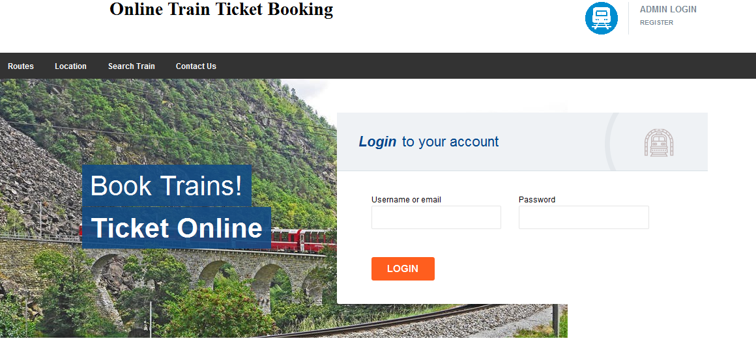

### **5.2.2 Login**

**A client or an admin**

For anyone who is registered in the system, they provide the login details i.e. username, password.

A client will login so as to be able to book a train ticket

An admin will login so as to be able to approve or disapprove clients.

Tasks of an admin

Approve or disapprove clients after they have booked tickets.

In charge of management of the entire system.

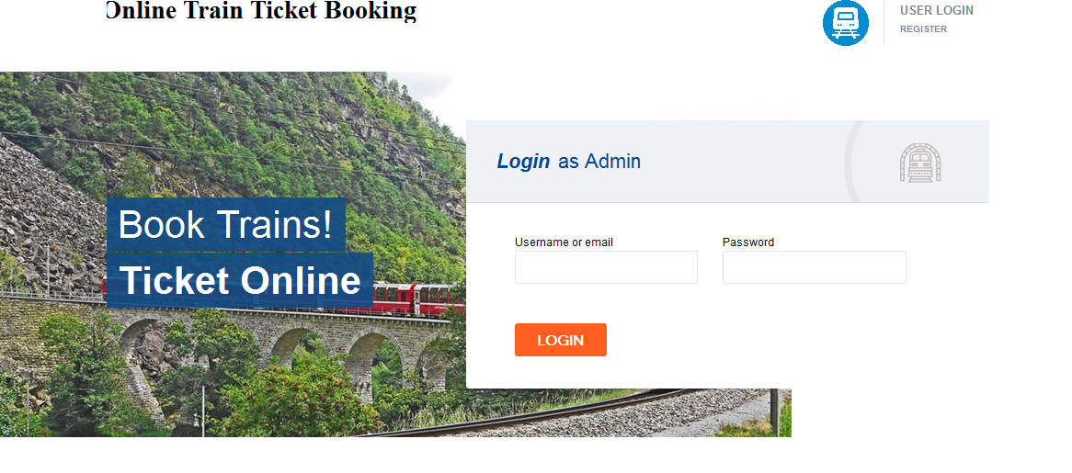

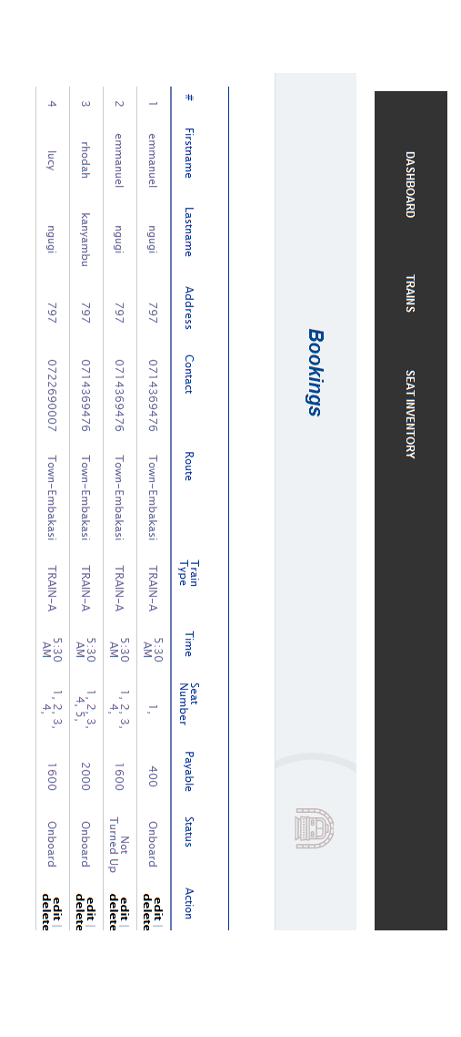

## **5.3 Summary conclusion and recommendations**

### **5.3.1 Summary**

The project involved development of an online train booking system. The system was expected to enable a client book from work place, the data will be sent to the administrator who will approve or disqualify the booking.

A client will be able to log in only if at all his/her information is available in the database thus when the username and password are illegible for log in.

### **5.3.2 Conclusion**

From the above discussion it can be noted that the main objective of implementing computer based system was realized as the work load of the users is drastically reduced.

The users of the system were able to create their profiles to enable them access the system, were able to register, log in and book. The users were also able to contact the system administrator and leave their comments.

The administrator was able to view, approve or disqualify clients booking.

### **Recommendation**

The project has a very vast scope in future. The system can be updated in near future as and when requirement for the same arises, as it is very flexible in terms of expansion. With the proposed train booking system ready and fully functional, the clients are now able to manage and hence run the entire work in a much better, accurate and error free manner.

Customization-In future the application can be generalized from its current customized status wherein other means can join hands on similar applications can utilize this software and make changes to it according to their needs. This may include development of an overall booking system.

# REFERENCEs

*Carbaugh, T. M.(2003) “Secretary of State Kevin Shelley Announces Directives To*

*Ensure railway Systems,” California Secretary of State,*

*Keller, A. M. Dechert, A.K, Auerbach K, Pearl, A, and Hall, J.K.(2005) “A PC-based Open-Source Booking Machine.*

*USENIX Annual Technical Conference, U.S.A., p.25*

*Kohno,T A. Stubblefield,Ribin,A. D and Wallach, D.S(2004) “Analysis of an Electronic Systems,” IEEE Computer Society p.27-40*

*Amankona, E. and Paatey, EK. (2009). Booking systems. Graduation Project, Wisconsin International University College, Ghana*

*Smith, A.D. and Clark, JS. (2005) Revolutionizing automation process through online strategies. Online Inform. Rev., 29(5): 513-530.*

*Neumann, P.G. (1993) Security Criteria for Electronic booking.16th National Computer Security Conference, Baltimore, Maryland, and September. Retrieved from India.*